# Project Design Phase-II

**Data Flow Diagram & User Stories**

|  |  |
| --- | --- |
| Date | 28 October 2022 |
| Team ID | PNT2022TMID36960 |
| Project Name | VirtualEye - LifeGuard for Swimming Pools to  Detect Active Drowning |
| Maximum Marks | 4 Marks |

## Data Flow Diagrams:

A Data Flow Diagram (DFD) is a traditional visual representation of the information flows within a system. A neat and clear DFD can depict the right amount of the system requirement graphically. It shows how data enters and leaves the system, what changes the information, and where data is stored.

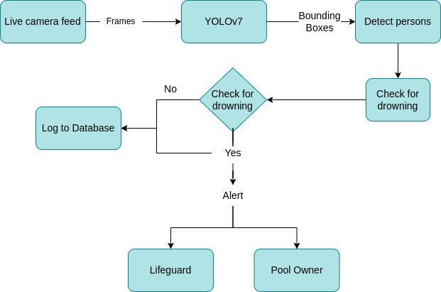

## User Stories

|  |  |  |  |  |  |  |
| --- | --- | --- | --- | --- | --- | --- |
| **User Type** | **Functional Requirement (Epic)** | **User Story Number** | **User Story / Task** | **Acceptance criteria** | **Priority** | **Release** |
| Customer  (Pool owner) | Installation | USN-1 | As a pool owner, I can install the cameras and  set up the drowning detection system | I can connect the cameras  to the cloud-hosted software | High | Sprint-1 |
|  | Detecting the drowning persons | USN-2 | As a user, I can find the drowning persons by using the drowning detection system | I would receive an alert if a person is drowning | High | Sprint-1 |
|  | Notify the lifeguard | USN-3 | As a user, I can notify the lifeguard when the system detects a drowning person | I can set up an alarm that would notify the lifeguard | High | Sprint-2 |
| Customer  (Lifeguard) | Rescue people | USN-4 | As a user, I can rescue the drowning persons  from the pool | I can save the drowning  person | High | Sprint-2 |
| Customer  (Swimmers) | Safety | USN-5 | As a user, I can swim without the fear of  drowning | I can swim safely with the  help of the system and the lifeguard | Medium | Sprint-2 |
| Customer Care  Executive | Contact | USN-6 | resolve technical issues | I can contact the customer  care executive to resolve any issues | Medium | Sprint-3 |
| Adminitsrator | Dashboard | USN-7 | Management of the drowning detection  system and database management. | I can access the system’s  logs and any other data instantly | High | Sprint-4 |